The task consited of making three games a Tic Tac Toe ,Hangman and Thetris game.In this documentation I will write a detail documentation on how it was done.

First, we start with the creation of the game board.I wrote a function gameBoard to print the game board use a for loop with a 2D array of size 3.

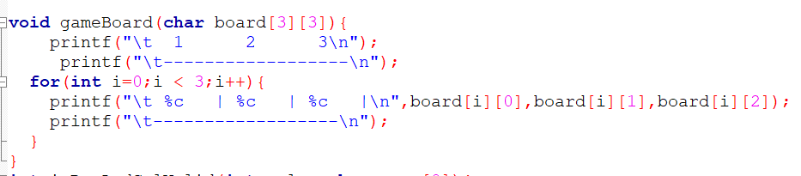

The next function is the isRowAndColValid function which checks if the row and column the user enters is valid or not and request him to re-enter the value and then return the value.The function takes some parameteres value and name.The value parameter take either the row or column to be evaluated while the name prints either row or column depending on the value entered when called.

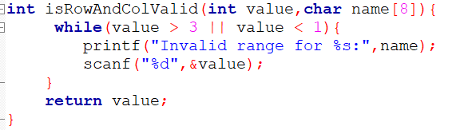

The checkWinner function takes care of checking who wins after a player input is completed by checking if the horizontal,vertical and diagonal columns are equal and if equal the player who wins is shown and the game is ended.

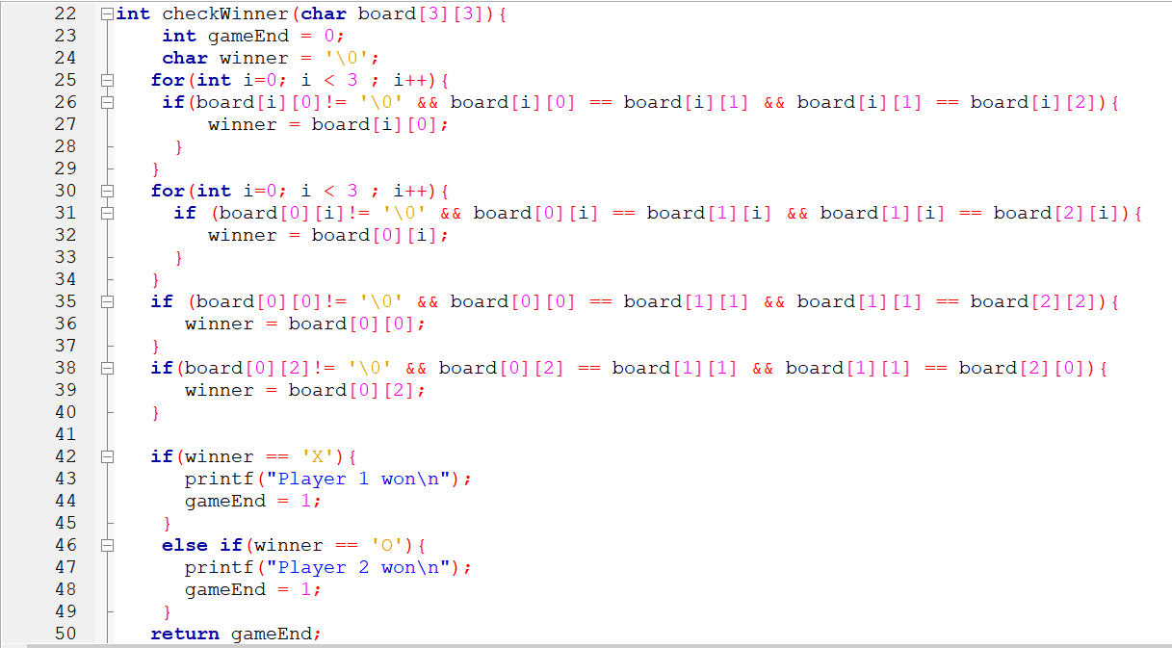

Then the main function which is the core part of the program where all instructions are executed.The needed variables are initalized and the gameboard function is called.The game enters a while loop control structure to continue the game while there is a win or a draw.The main function contains functions shown above to ensure that the user enter valid information to be process by the check win function checkWinner and also interchange between players.

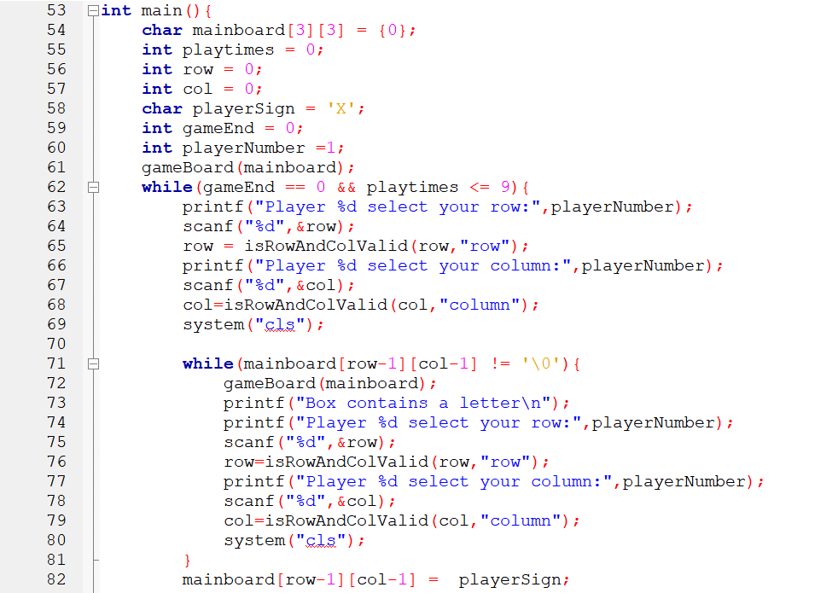

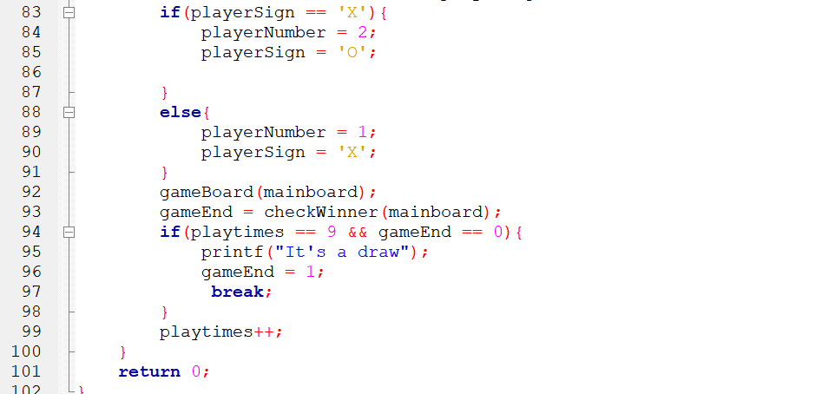

The Difficulties Encountered

Firstly,The design of the game board I tried to replicate the design my senior showed

But I was unable to do it so I went in for a simple game board which is almost good since the numbers shift when an input is made.

Secondly,I had difficulties in implementing all the verifications on if the input coordinate already had a letter and the range of input so decided to make the isRowAndColValid function to check the range and include the the check to know if full in the main function.